# C81MST Lab class 9: creating the IOR experiment in PsychoPy

We need:

* A fixation cross/spot (controlling eye gaze will be important here)
* A target (another cross?) that could be on left or right
* A method for subjects to respond (keyboard)
* A **pair of rectangles** (left and right, to help locate the target in space)
* A **cue** (we’ll draw a yellow square, bigger than the locating rectangles and behind them in depth)

Rough object timings:

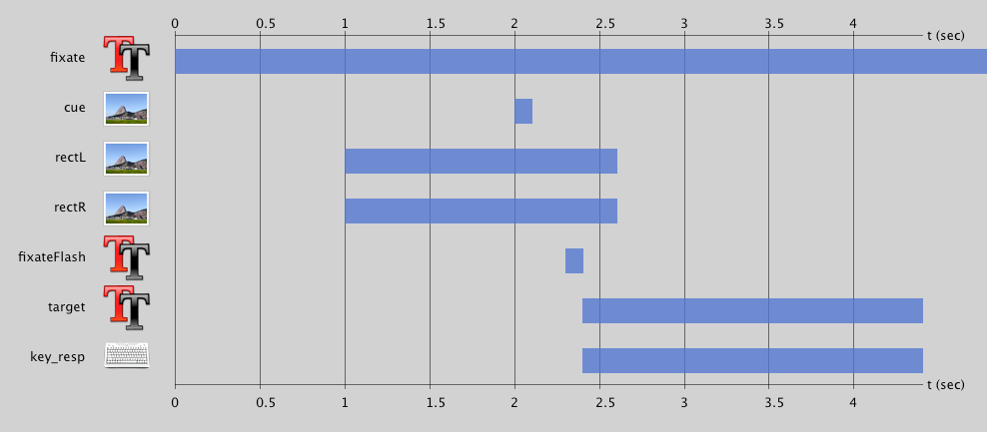

And with this spatial layout:

1. Open PsychoPy and create a new experiment
2. Create a new folder (e.g. on your personal network space) and save your new experiment there straight away